**STATE OF THE MARKET**

**MORTGAGE POOL OVERVIEW**

**Pool Factor, Cumulative Prepay Rate, Cumulative Default Rate**

**Note:** Fannie Mae loan level credit data includes loans originated from loan age from 2 to 80. The percentages are weighted by loan count and the data are for each quarter.

The pool factor decreases stably over the past 80 months, with a slowly increasing cumulative default rate residential and a stably increasing cumulative prepay rate.

**Average Mortgage Interest Rate vs. Bank Interest Rate**

**Note:** Fannie Mae loan level credit data includes loans originated from Q4 2012 to Q3 2018.

The average mortgage interest rate is stable around 2 to 3 percent, and the bank interest rate also slightly fluctuates between 3.4 to 3.44, similar to the value of mortgage interest rate.

**Conditional Prepay Rate vs. Interest Rate**

**Note:** Fannie Mae loan level credit data includes loans originated from Q4 2012 to Q3 2018. The percentages are weighted by loan balance and the data are for each quarter.

**Relative Change of Conditional Prepay Rate vs. Interest Rate**

**Note:** Fannie Mae loan level credit data includes loans originated from Q1 2013 to Q3 2018. The percentages are weighted by loan balance and the data are for each quarter.

The interest rate has a negative effect on the conditional prepay rate, and the decrease of interest rate leads to the increase of conditional prepay rate. The relative change plot and the correlation between two relative changes shows that the conditional prepay rate change lag behind the interest rate change, approximate 6-month lag between them.

**Conditional Default Rate vs. House Price Index**

**Note:** Fannie Mae loan level credit data includes loans originated from Q1 2013 to Q3 2018. The percentages are weighted by loan balance and the data are for each quarter.

**Relative Change of Conditional Default Rate vs. House Price Index**

**Note:** Fannie Mae loan level credit data includes loans originated from Q1 2013 to Q3 2018. The percentages are weighted by origination balance and the data are for each quarter.

Generally, the house price index decreases, while conditional default rate increases over the year 2013 to 2018. Also, the relative change is not on the same scale, while the relative change in conditional default rate is very volatile, the relative change in house price index is much less.

**SPECIAL FEATURE**

**FANNIE MAE COMPOSITION**

**Balance on 30-year, Fixed-rate, Full-doc, Amortizing Loans**

|  |  |  |  |  |  |  |
| --- | --- | --- | --- | --- | --- | --- |
| **Origination Year** | **Origination FICO** |  | **LTV** |  |  | **Total** |
|  |  | **≤70** | **70 to 80** | **80 to 90** | **>90** |  |
|  | ≤700 | 2.59% | 2.89% | 0.58% | 0.63% | 6.69% |
| **2012** | 700 to 750 | 7.17% | 10.50% | 2.33% | 2.78% | 22.78% |
|  | 750 to 800 | 21.40% | 25.40% | 4.52% | 4.58% | 55.90% |
|  | >800 | 6.99% | 6.11% | 0.84% | 0.68% | 14.62% |
|  | Total | 38.15% | 44.91% | 8.26% | 8.67% | 100.00% |
|  | ≤700 | 2.72% | 2.88% | 0.61% | 0.68% | 6.89% |
| **2013** | 700 to 750 | 7.39% | 10.60% | 2.47% | 2.79% | 23.25% |
|  | 750 to 800 | 21.25% | 24.28% | 4.93% | 4.59% | 55.06% |
|  | >800 | 7.24% | 5.98% | 0.94% | 0.64% | 14.80% |
|  | Total | 38.60% | 43.75% | 8.94% | 8.70% | 100.00% |
|  | ≤700 | 3.84% | 2.47% | 0.00% | 2.14% | 8.45% |
| **2014** | 700 to 750 | 13.50% | 14.02% | 2.06% | 0.00% | 29.57% |
|  | 750 to 800 | 16.18% | 27.17% | 4.34% | 2.37% | 50.07% |
|  | >800 | 5.93% | 5.98% | 0.00% | 0.00% | 11.91% |
|  | Total | 39.45% | 49.64% | 6.40% | 4.51% | 100.00% |
|  | ≤700 | 0.00% | 0.00% | 0.00% | 0.00% | 0.00% |
| **2015** | 700 to 750 | 32.21% | 0.00% | 0.00% | 0.00% | 32.21% |
|  | 750 to 800 | 49.81% | 0.00% | 0.00% | 0.00% | 49.81% |
|  | >800 | 17.98% | 0.00% | 0.00% | 0.00% | 17.98% |
|  | Total | 100.00% | 0.00% | 0.00% | 0.00% | 100.00% |
|  | ≤700 | 0.00% | 0.00% | 0.00% | 0.00% | 0.00% |
| **2016** | 700 to 750 | 0.00% | 0.00% | 0.00% | 0.00% | 0.00% |
|  | 750 to 800 | 100.00% | 0.00% | 0.00% | 0.00% | 100.00% |
|  | >800 | 0.00% | 0.00% | 0.00% | 0.00% | 0.00% |
|  | Total | 100.00% | 0.00% | 0.00% | 0.00% | 100.00% |
| **Total** | | 63.24% | 27.66% | 4.72% | 4.38% | 100.00% |

**Note:** Fannie Mae loan level credit data includes loans originated from Q3 2012 to Q1 2018. The percentages are weighted by origination balance. The analysis included only mortgages with original terms of 241-420 months.

Since 2012, the composition of loans purchased by Fannie Mae has been stable, which shifted towards borrowers with higher FICO scores since 2008. Most of the loans have a FICO scores in the range of 700 to 800, contributing to around 50 percent of loans originated from 2012 Q3 to 2018 Q1.

**Negative Equity Share**

**Note:** Negative equity rate is the percent of all residential properties with a mortgage in negative equity. Loans with negative equity refer to loans above 100 percent LTV. Loans near negative equity refer to loans above 95 percent LTV. Last updated December 2017.

With housing prices continuing to appreciate, residential properties in negative equity (LTV greater than 100) as a share of all residential properties with a mortgage continued to decline.

**SPECIAL FEATURE**

**FANNIE MAE DELINQUENCY & DEFAULT**

**Loans in Serious Delinquency/Foreclosure**

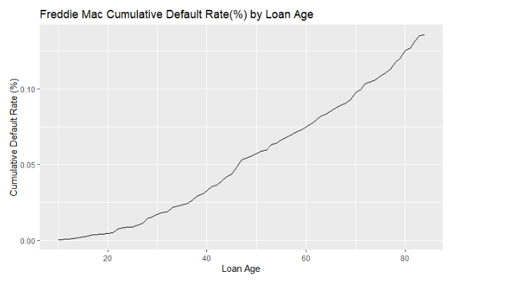

**Note:** The analysis included only mortgages with original terms of 241-420 months.

With cleaner books of business and the housing recovery underway, for Freddie Mac’s 2012-2018 vintages, cumulative defaults total around 0.15 percent.

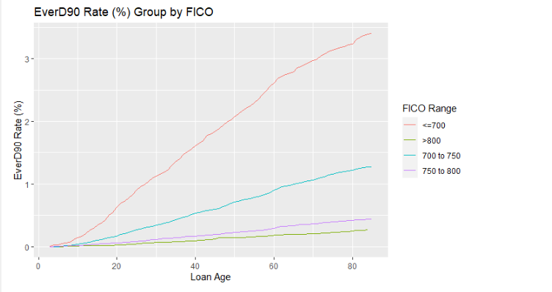

**Note:** The analysis included only mortgages with original terms of 241-420 months.

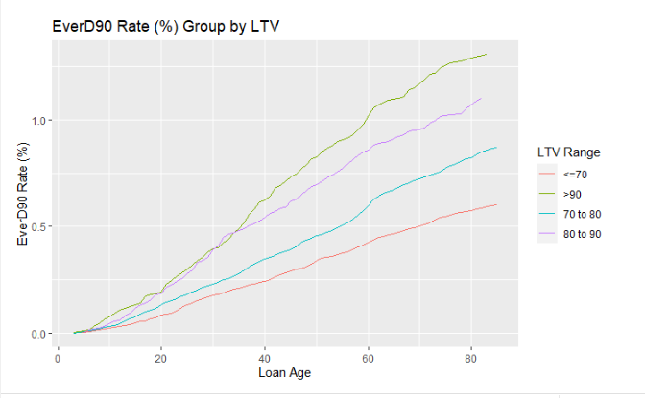

**Note:** The analysis included only mortgages with original terms of 241-420 months.

The cumulative default rate is the lowest for the group with LTV<=70 and FICO scores>800 for Freddie Mac’s 2012-2018 vintages, cumulative defaults total around 0.15 percent.

**Default Rate on 30-year, Fixed-rate, Full-doc, Amortizing Loans**

|  |  |  |  |  |  |  |
| --- | --- | --- | --- | --- | --- | --- |
| **Origination Year** | **Origination FICO** |  | **LTV** |  |  | **Total Average** |
|  |  | **≤70** | **70 to 80** | **80 to 90** | **>90** |  |
|  | ≤700 | 12.20% | 18.12% | 3.54% | 0.042393 | 9.52% |
| **2012** | 700 to 750 | 7.32% | 13.14% | 4.96% | 6.41% | 7.96% |
|  | 750 to 800 | 6.40% | 11.75% | 1.52% | 5.04% | 6.18% |
|  | >800 | 1.89% | 1.83% | 0.74% | 0.89% | 1.34% |
|  | Total Avgerage | 6.95% | 11.21% | 2.69% | 4.15% | 6.25% |
|  | ≤700 | 11.59% | 12.23% | 3.19% | 4.39% | 7.85% |
| **2013** | 700 to 750 | 9.15% | 16.91% | 5.65% | 5.99% | 9.42% |
|  | 750 to 800 | 6.47% | 12.68% | 3.01% | 3.94% | 6.53% |
|  | >800 | 1.92% | 2.32% | 0.41% | 0.16% | 1.20% |
|  | Total Avgerage | 7.28% | 11.03% | 3.07% | 3.62% | 6.25% |
| Total Avgerage | | 7.12% | 11.12% | 2.88% | 3.88% | 6.25% |

**Note:** Fannie Mae loan level credit data includes loans originated from Q3 2012 to Q1 2018. The percentages are weighted by origination balance. The analysis included only mortgages with original terms of 241-420 months.

Originations from 2012 and later have pristine credit characteristics and a more favorable home price environment, contributing to the low default rates.

**SPECIAL FEATURE**

**LOSS SEVERITY**

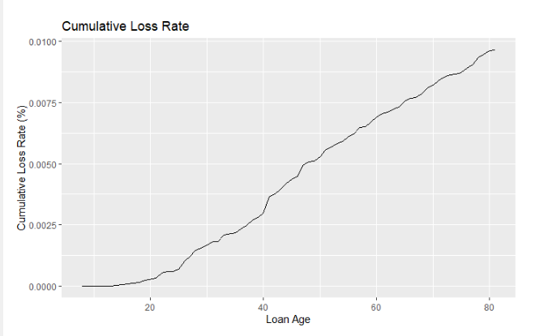

**Note:** Fannie Mae loan level credit data includes loans originated from loan age from 2 to 80. The percentages are weighted by original balance and the data are for each quarter.

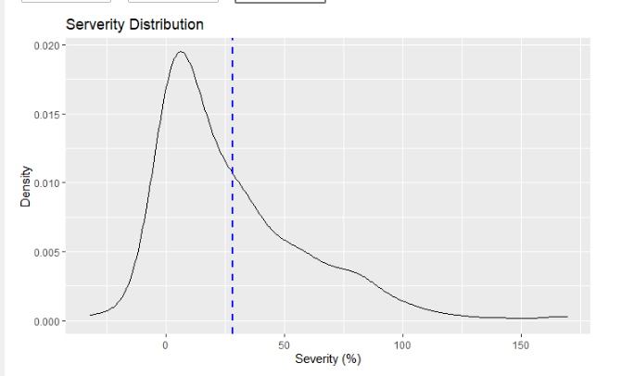

**Note:** Fannie Mae loan level credit data includes loans originated from loan age from 2 to 80. The percentages are weighted by original balance and the data are for each quarter.

The density distribution indicates that majority of loans has recovery range between 0% to 100% and the mean value is 28.01%.

**Freddie Mac - Liquidation Rates and Severities for D180+ loans**

|  |  |  |  |  |  |  |  |  |  |
| --- | --- | --- | --- | --- | --- | --- | --- | --- | --- |
| Origination Year | Number of Loans | | | Mean defaulted UPB ($) | | | Severity | | |
| All | REO | Foreclosure Alternatives | All | REO | Foreclosure Alternatives | All | REO | Foreclosure Alternatives |
| 2012 | 118 | 61 | 57 | 149442.16 | 137298.74 | 162437.74 | 26.89% | 38.07% | 15.29% |
| 2013 | 200 | 94 | 106 | 145072.86 | 150173.36 | 140549.78 | 28.67% | 34.96% | 23.01% |
| All | 318 | 155 | 163 | 147257.51 | 143736.05 | 151493.76 | 27.78% | 36.52% | 19.15% |

**Note:** Freddie Mac loan level credit data includes loans originated from Q3 2012 to Q1 2018, with performance information on these loans through Q4 2019.

The table shows the severity of Freddie loans that have liquidated, broken down by liquidation channel and vintage year. Foreclosure alternatives, including short sales, note sales, and third-party sales have higher defaulted unpaid principal balance (UPB) and much lower loss severities than REO sales.